# ABC’s Inventory Management System

## Test Script

|  |  |  |  |  |  |
| --- | --- | --- | --- | --- | --- |
| **Test Name** | | Send Correct Quantity Of Product By Searching Unknown Product Item Code To The Destination (Test Case SPT004) | | | |
| **Use Case Tested** | | Send Product | | | |
| **Test Description** | | This test tests if the system can search the unknown product item code, an alert will be displayed if product does not exist in current location. | | | |
| **Pre-Conditions** | | Meta data must exist, product and product details like product item code, location ID and product quantity. | | | |
| **Post-Conditions** | | Appropriate Alert Message is displayed. | | | |
| **Notes** | | This test assumes that the user does not know the destination name, product item code. | | | |
| **Result (Pass/Fail/Warning/ Incomplete)** | | Pass | | | |
|  | **Test Step** | | **Expected Test Results** | **P** | **F** |
| 1. | Select Send Product Button from home page | | Display the Send Product page | P |  |
| 2. | Select the destination location | | Destination location combo box changes to the selected location name | P |  |
| 3. | Enter the description for this transfer | | Description text area displays user inputs | P |  |
| 4. | Enter the unknown product item code in search field and hit search button | | System display the alert message to notify user that the product does not exist in current location | P |  |

## Data Set 1

|  |  |  |  |
| --- | --- | --- | --- |
| **Test Data Table** | | | |
| **Destination Location** | Oxford Store | | |
| **Description** | Send Product From Warehouse to Oxford Store | | |
| **Product Item Code** | S2100 | abc | 2300 |
| **Quantity** | N/A | N/A | N/A |

# Result Screenshots

The screenshots of the result on each test step for each data set are given below:

**Step 1**

Select the destination location

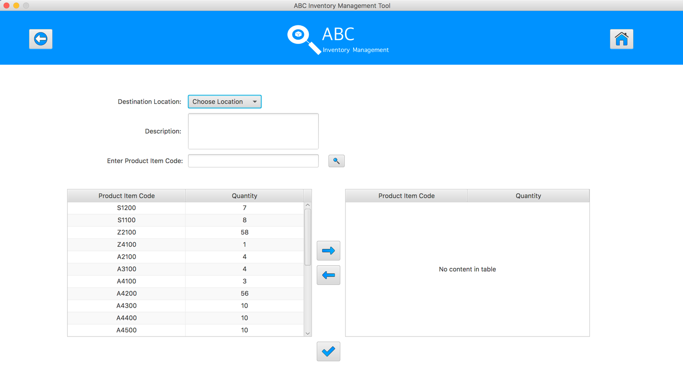

**Step 2**

Enter the description for this transfer

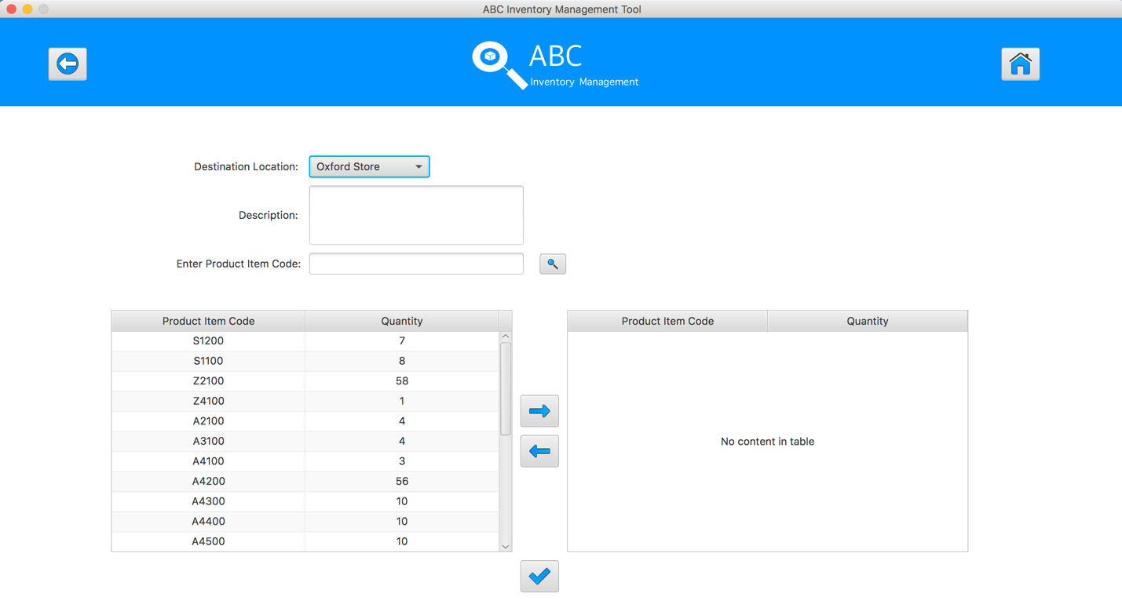

**Step 3**

Select the product item code in the table on the left

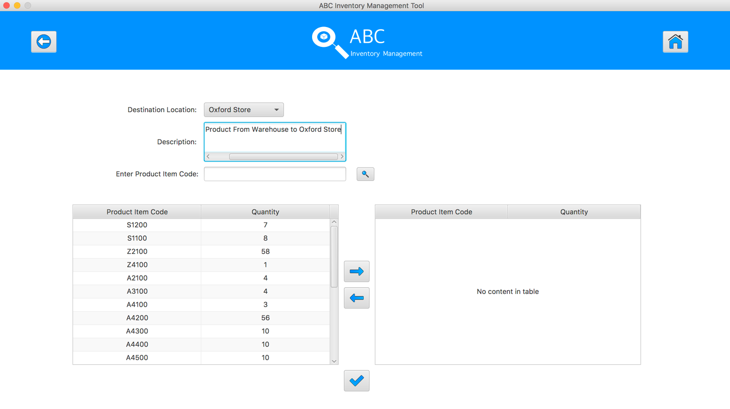

**Step 4**

Enter the product item code in search field and hit search button, an alert message will be displayed.

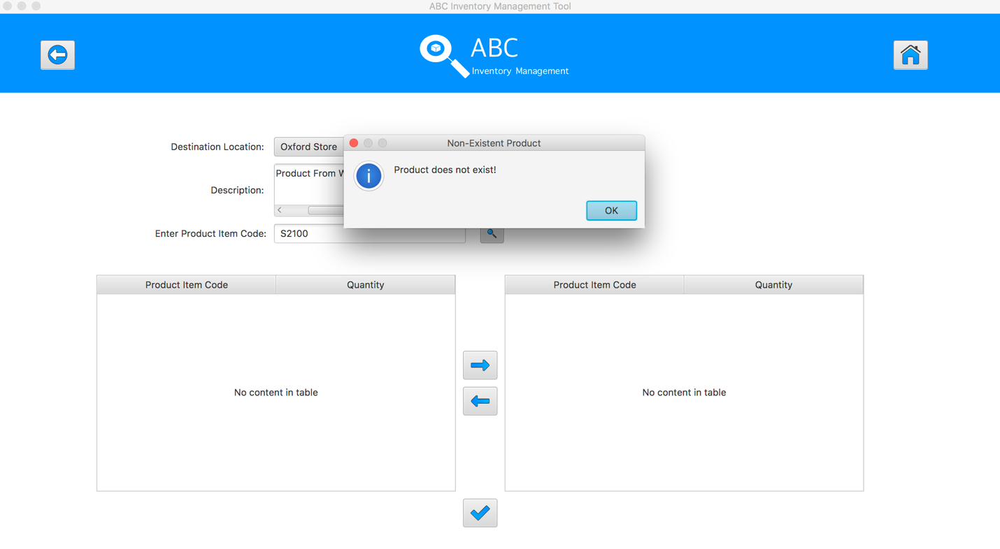

**Step 5**

Enter the product item code in search field and hit search button, an alert message will be displayed.

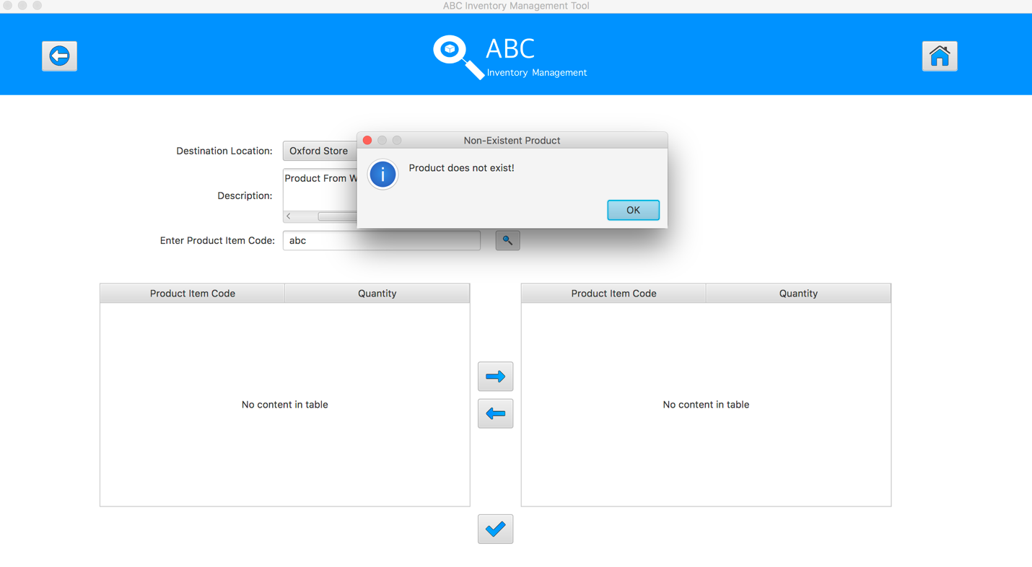

**Step 6**

Enter the product item code in search field and hit search button, an alert message will be displayed.

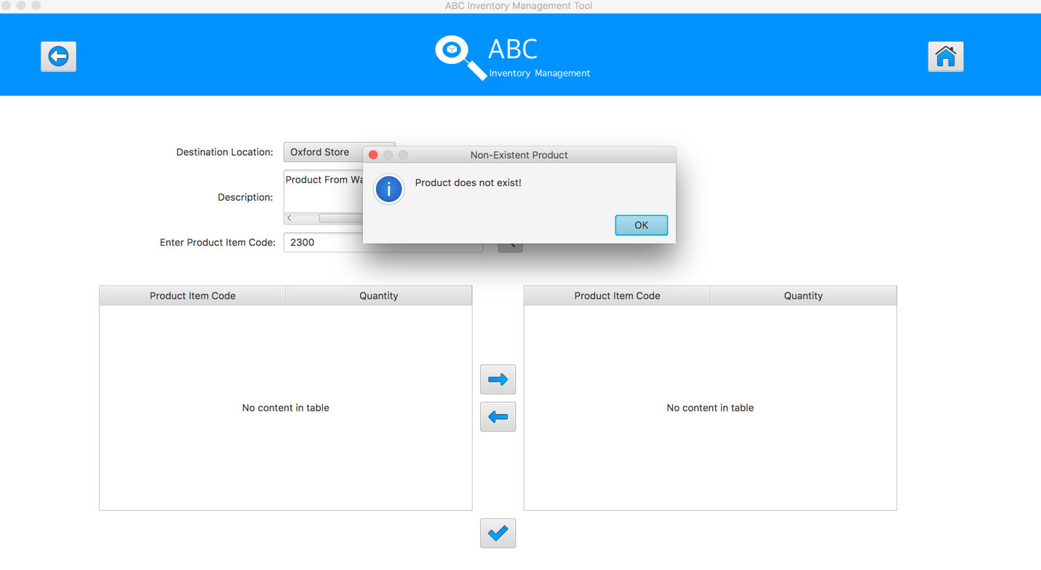

## Data Set 2

|  |  |  |  |
| --- | --- | --- | --- |
| **Test Data Table** | | | |
| **Destination Location** | Epping Store | | |
| **Description** | Send Product From Warehouse to Epping Store | | |
| **Product Item Code** | -345 | SA222 | *“leave blank”* |
| **Quantity** | N/A | N/A | N/A |

# Result Screenshots

The screenshots of the result on each test step for each data set are given below:

**Step 1**

Select the destination location



**Step 2**

Enter the description for this transfer

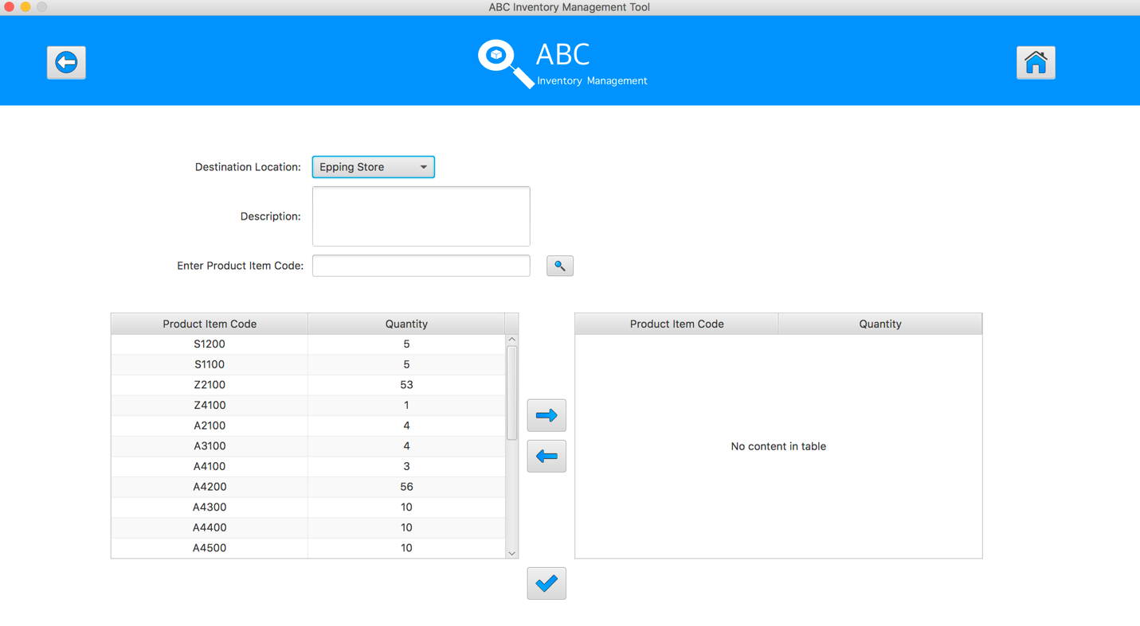

**Step 3**

Select the product item code in the table on the left

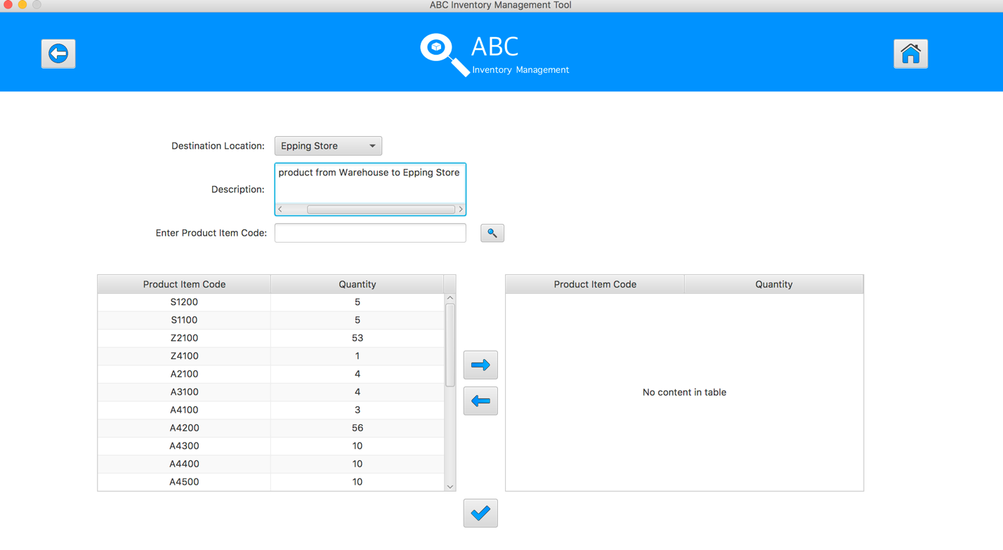

**Step 4**

Enter the product item code in search field and hit search button, an alert message will be displayed.

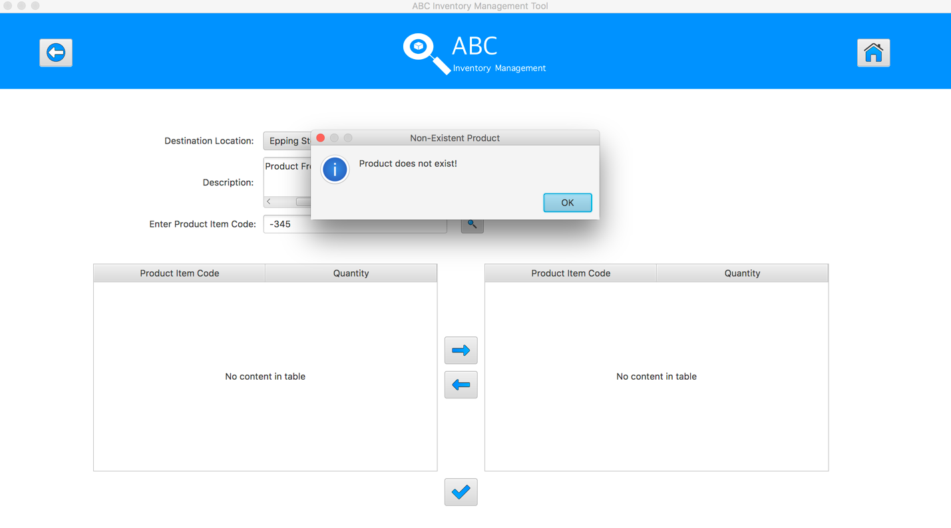

**Step 5**

Enter the product item code in search field and hit search button, an alert message will be displayed.

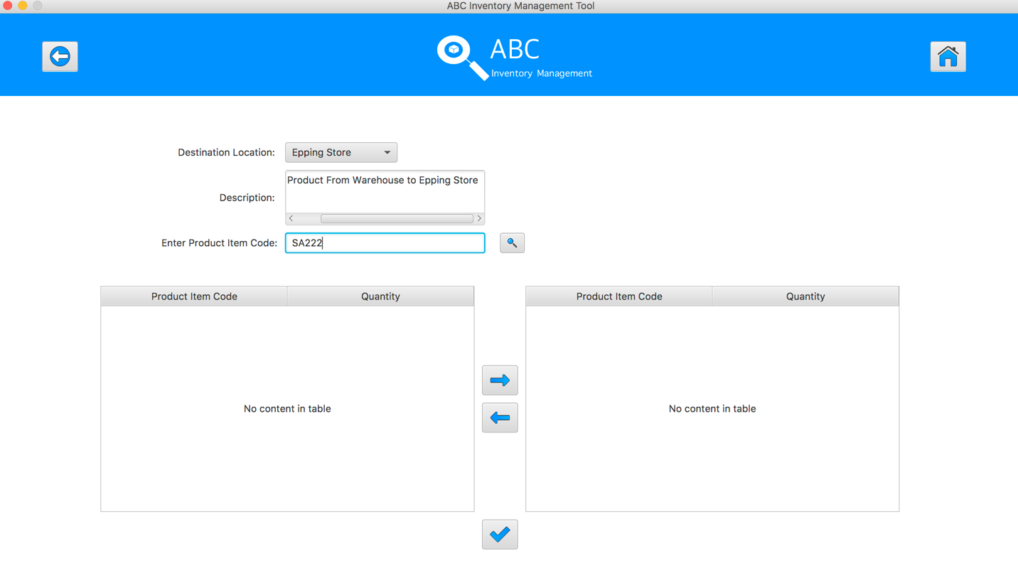

**Step 6**

Does not enter anything in search field and hit search button, the system will show all the products of sending location.

